**TRAINING REPORT**

on

**WEB DEVELOPMENT**

Submitted in partial fulfillment of the

Requirements for the award of

**Degree of Bachelor of Technology in Computer Science & Engineering**



Submitted By

Name: HRISHAV KUMAR SAO & AVISHEK KUMAR

University ID: 18BCS2140 & 18BCS2153

Training Group: CSE-13

**SUBMITTED TO:**

**Department of Computer Science & Engineering**

Chandigarh University

Gharuan, Mohali

**CONTENTS:**

|  |  |  |
| --- | --- | --- |
| **Sr. No.** | **Topic** | **Page No.** |
| **1.** | **Introduction to Project** | **3** |
| **2.** | **Apparatus** | **4** |
| **3.** | **Snapshots** | **5** |
| **4.** | **Result** | **10** |
| **5.** | **Conclusion** | **12** |

**INTRODUCTION:**

The task provided in hand to us included making of a working model of a website with multiple web pages. This in contrast should be presented with the use of HTML scripting language alongside CSS for styling & formatting. The application of JavaScript is a condition in making of this Project.

In our Project, our team of two i.e. Hrishav Kumar Sao & Avishek Kumar, has split the work between and have implemented a link hosting website for popular Anime Films & Series. The website as of now holds links to several renowned selections in the space, the pages contain graphical representation of the Anime’s snapshot & plot line of the movie/series. An Index or Catalogue has been made in order to make it easy to navigate & search the matter of choice. We also integrated a Login & Sign Up system to access the Catalogue and hence maintain a datasheet in the form of an SQL database of the traffic that visited “The Catalogue”.

The user on visiting the main site, is treated with an attractive Home Page with Navigation to most of the already available content on the website which includes and is not limited to:

* The Home Page itself.
* The Login Page.
* The Sign-Up Page for New Traffic.
* Forgot Password Window in order to request new password.
* About Section which includes information about reasons for creation of this page & credits.
* A Hidden Easter Egg wiz. Hidden 😊

The combined effort resulted into this minimalistic yet attractive webpage which provides information & material both at one place!

----------------------------------------------------------------------------------------------------------------

**THE APPARATUS:**

The Website is mostly based upon HTML and CSS. HTML acts as the backbone to the page & CSS is used to enhance the appearance and attract the minds of the Traffic to our site.

We also used a bit of JavaScript as it was a given compulsion to use JavaScript on our page.

The basic scripting was done on Visual Studio Code by both the creators & was debugged using Mozilla Firefox by Hrishav and Chrome by Avishek.

This project was done under supervision of our coordinators/teachers and with the help of material online like YouTube, CSSMasters, W3Schools, Community of GeeksForGeeks & Articles on related configurations used in the Project available freely* on books.google.com.

Visual Studio Code uses the concept of Extensions and thus I would like to include these which were used & were very helpful in our duly presented project:

* Beautify
* HTML CSS Snippets
* IntelliSense for CSS
* JavaScript (ES6) Code Snippets

----------------------------------------------------------------------------------------------------------------

**SNAPSHOTS:**

**0..**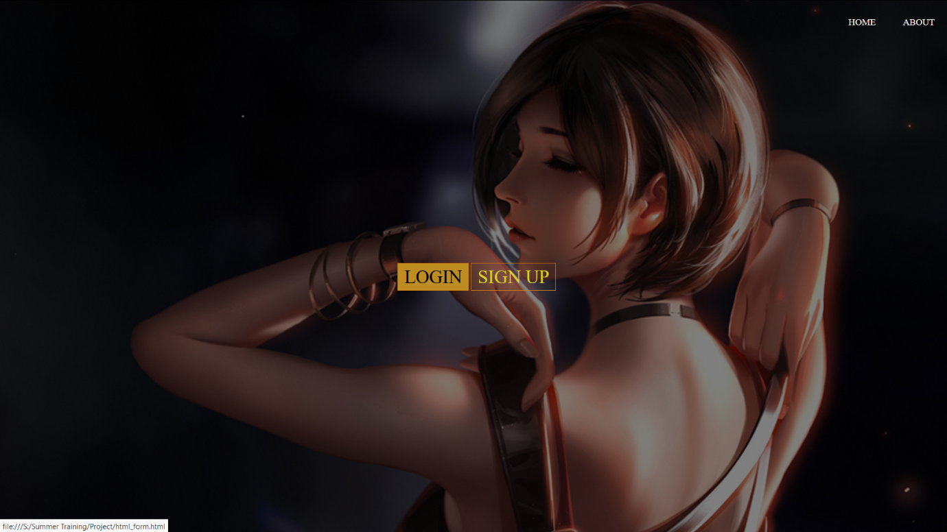

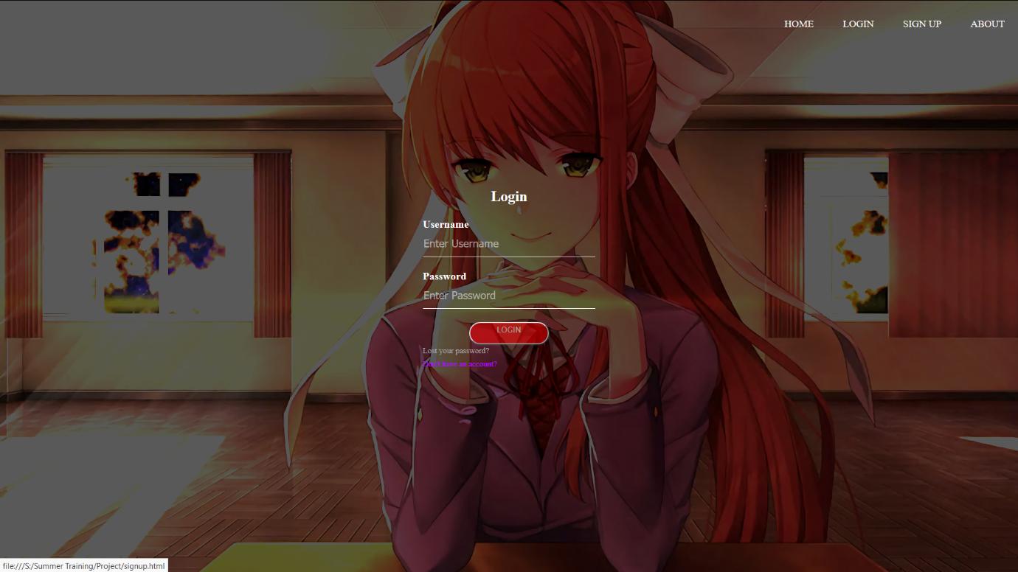

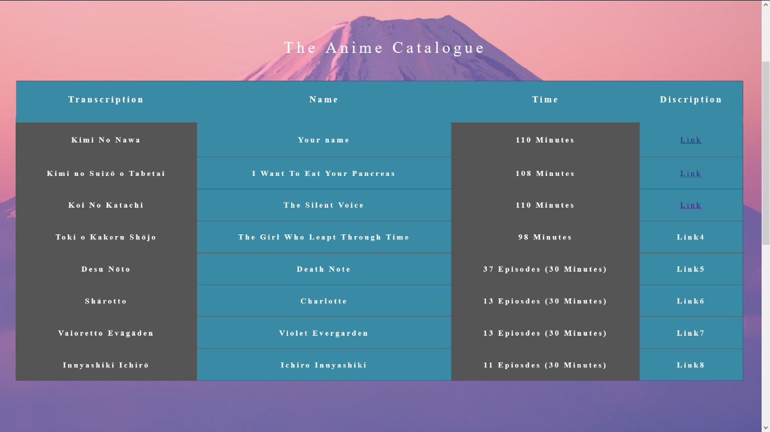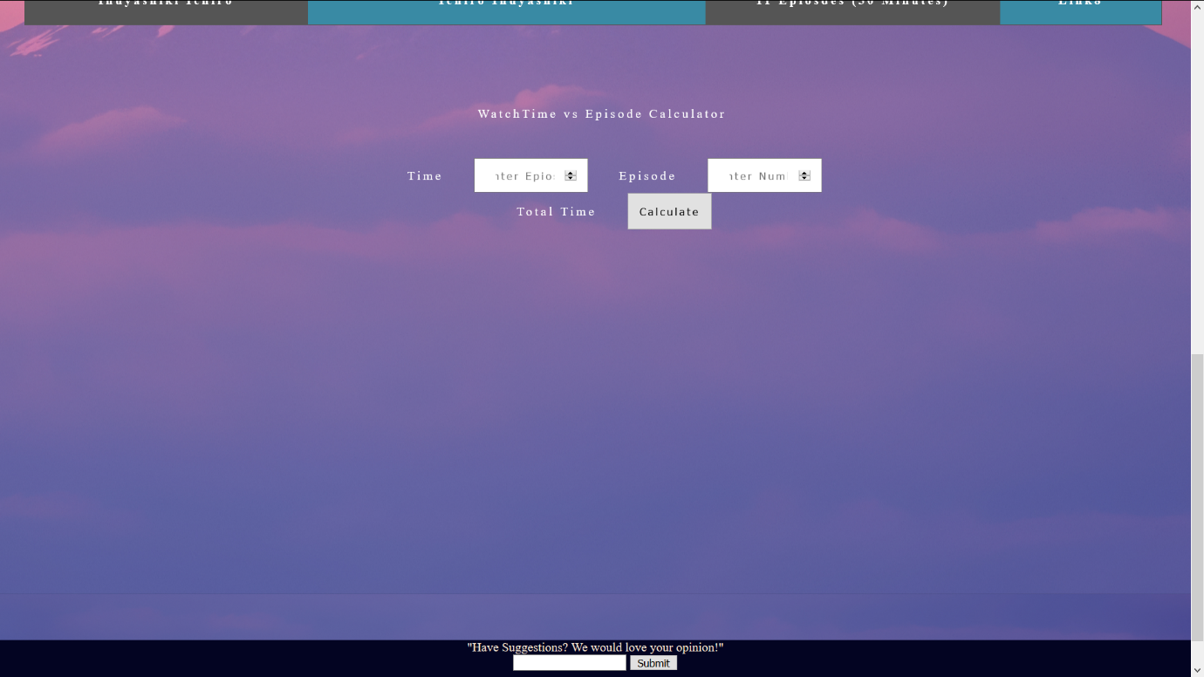

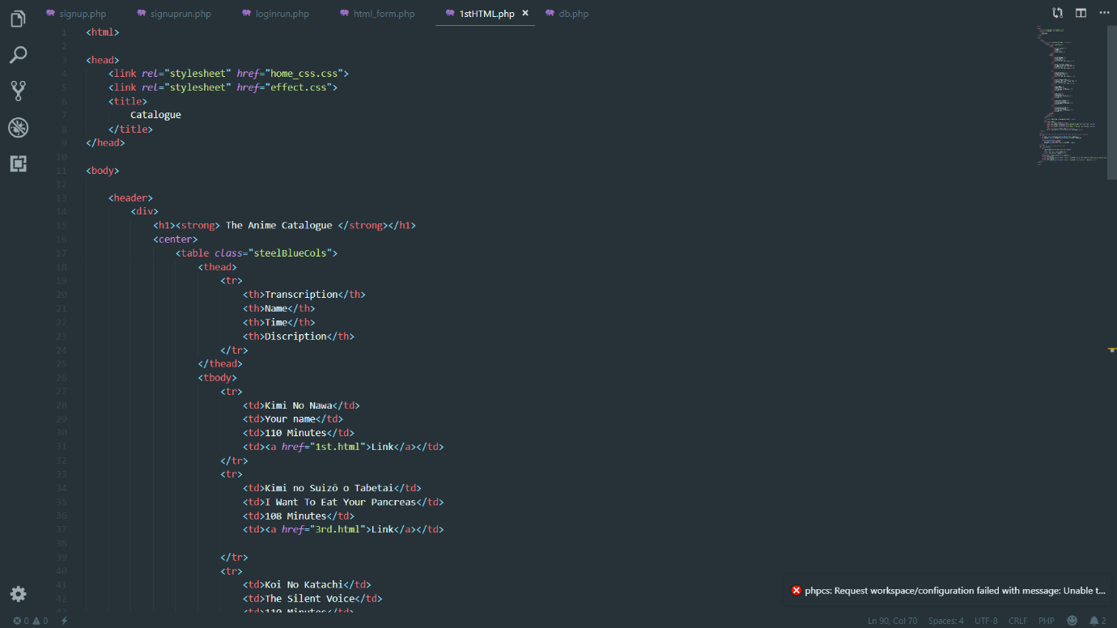

**.**

**.**

**.**

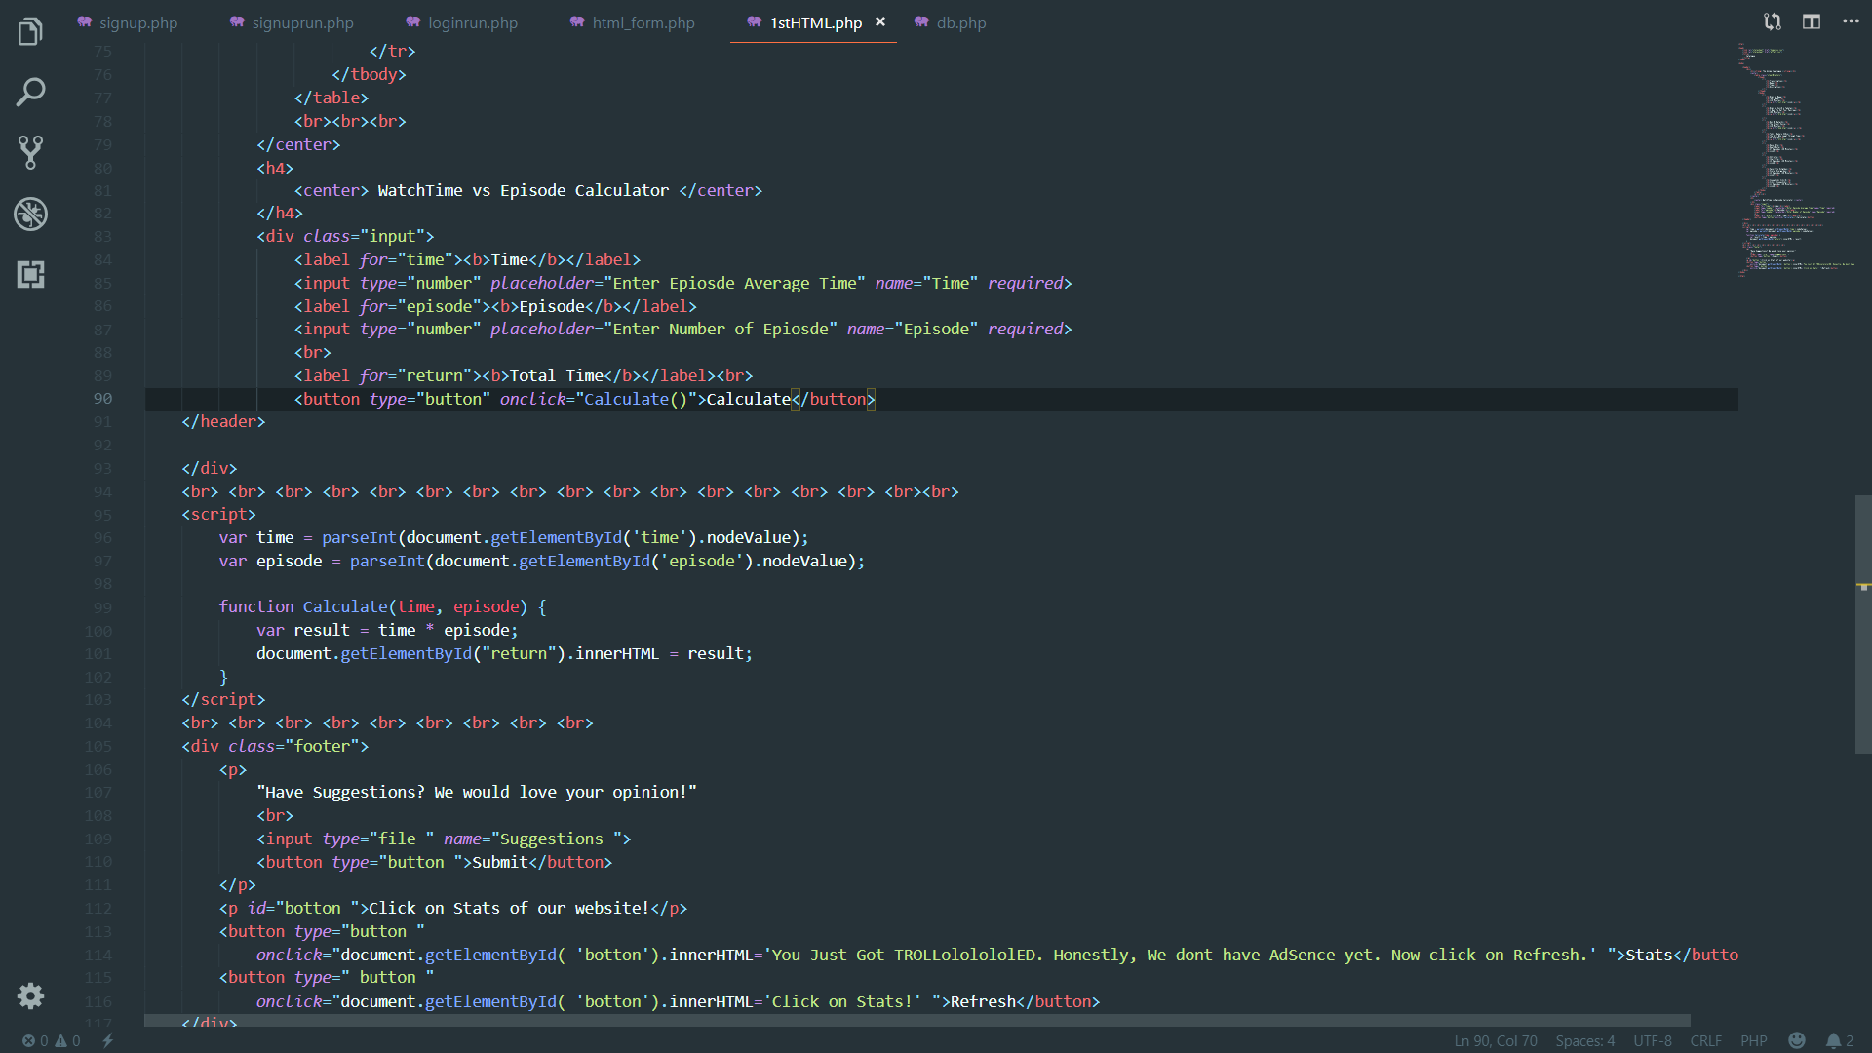

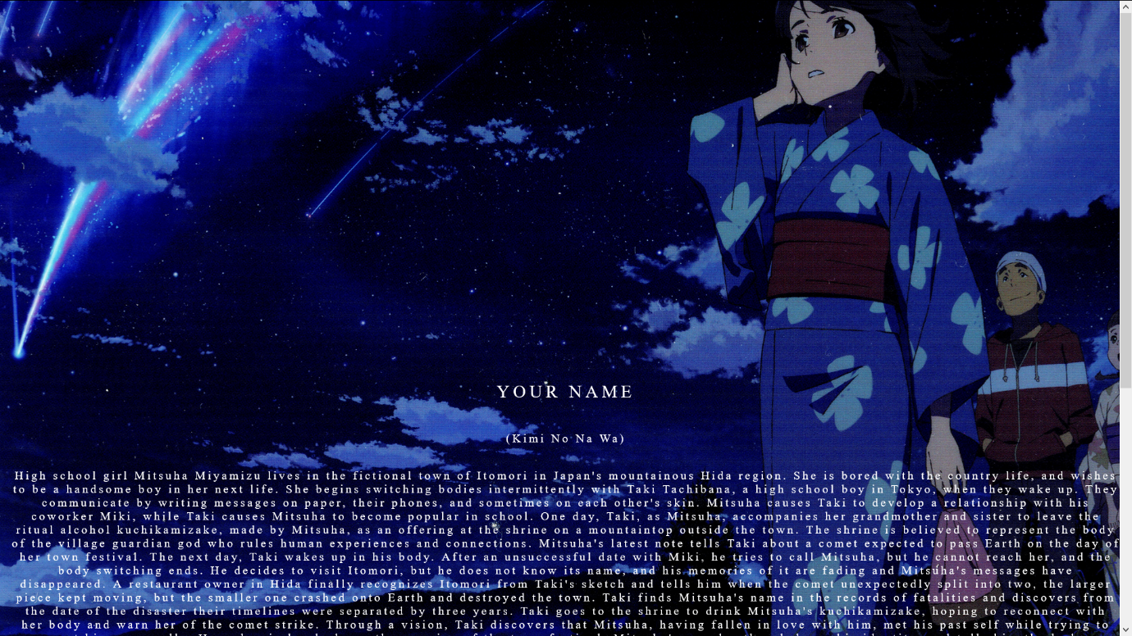

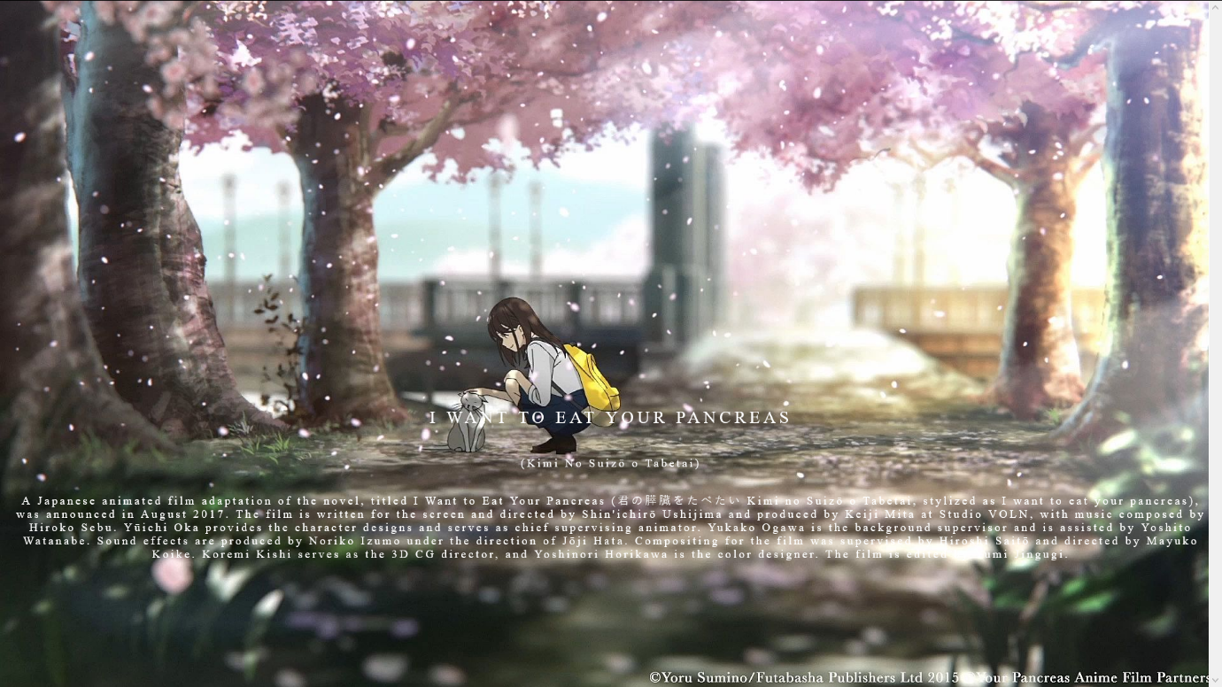

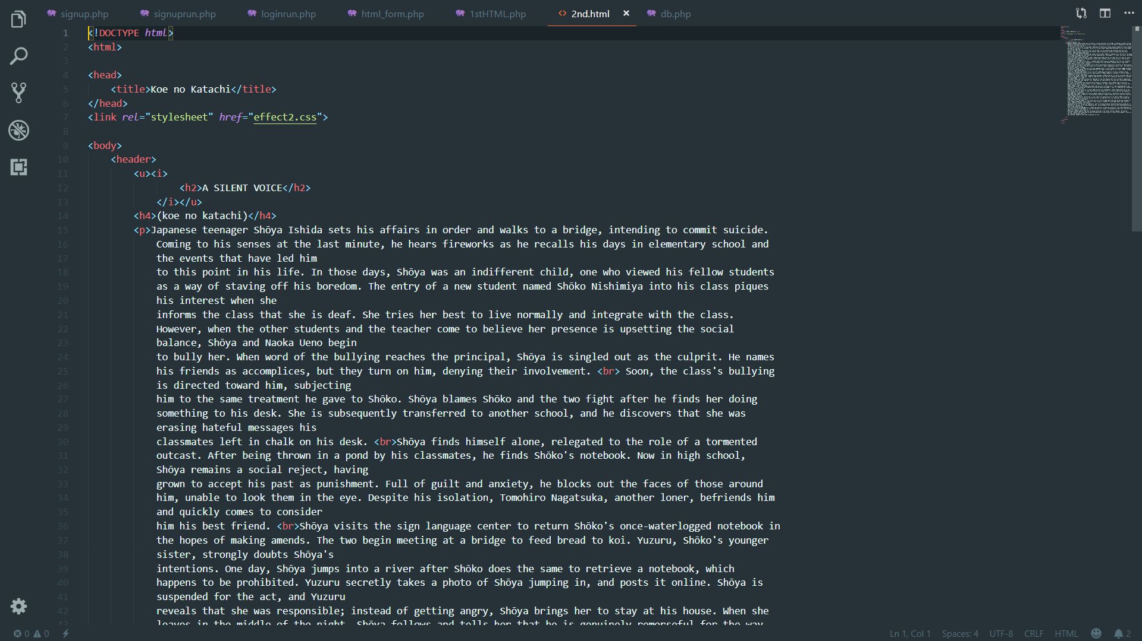

**Project Links:**

**Folder: https://drive.google.com/open?id=1cxQrCuM3Hmsoa31Y2ExKAMLUoLSNyC7f**

----------------------------------------------------------------------------------------------------------------

**RESULT:**

We would like to present a brief discussion and development in this section.

* 1. **The Starting Product:**

At first, the basics were brushed up by the training session of the 1st week which resulted in a barebones HTML scripted webpage which lacked any pop and attractive nature which would be a great thing for those using legacy browsers but in today’s era, everybody has modern software to compile & run task heavy web pages.

Thus, we stopped at the barebone structure of our website & put a halt to the development.

* 1. **After HTML 5 Style exertion:**

The advancements in HTML till today has been phenomenon and hence we used <style> to tackle the bare on look of the website. Style tag opened up many doors.

Until now, we only had our Login page and Forgot Password page made up on basic HTML scripts. But HTML 5 with its features fascinated us in many ways and our pursuit to make a webpage got a kickstart again.

This in turn led to the making of the actual Catalogue page. This included a table which stored the names, transcription in Japanese & Links to their respective pages.

The Table, although made on HTML 5 using <style> tag was still far from satisfactory. Hence, we stopped on the making yet again.

1. **CSS Entry to Workspace:**

The Introduction of CSS changed everything! Apart of being a pretty vast extension, it comprised tools to customize the webpage to another level. This was a huge stepping stone in the development of this webpage. Since, CSS comprised of such huge library of customizing tools, we felt overwhelmed and started with making the design better with the tools taught to us. Due to time constraints, it was impossible to explain and show all the commands and tools in class so we improvised and used the information available on YouTube & GeeksForGeeks to make an effort.

The scenario was now to make use of as much effects & transitions possible to make our website pop. But, in the end, we decided not to make deliberate measures & stick to our minimalistic design of our webpages, since the plethora of effects we so overwhelming that the content was crucially low & impacted the overall aesthetics.

Japanese Anime are known for there simplistic approach towards film making & that in turn impacts the audience more. Hence, we stuck with our guts to maintain a balance for the ambience appearance.

1. **JavaScript:**

Introduction to JavaScript was different and we didn’t have any experience with it. Hence, while practicing most of the stuff got haywire and had to be redesigned. Thus, we stuck once again to the minimalist approach and used it as the calculator on the catalogue page & created slideshows of the interesting shots of the particular movie/series.

1. **Final Presentation:**

After a period of 4 weeks, it was finished with all the bugs taken care of and we specially took care of our JavaScript modules which were giving us a hard time.

The SQL integration was still on hold as it was not clear to properly implement it with our webpages. Hence, a pure original creation of the team on the subject of Online Distribution was made true.

This is not the end and we plan to make several changes and renovations to the project to give it the best possible aesthetics.

----------------------------------------------------------------------------------------------------------------

**FUTURE OUTLOOK:**

We look forward to update this website further & make it more appealing to the community.

Hence, we look forward to make more improvements and add elements further to which the community can appreciate.

We find it pleasing enough to host a small number of links and information but with more time we believe we can make it into a corporate standard website which can boast ads and help in the revenue department. Furthermore, the information on the website about the various Anime are basic and we would like to keep it that way. The plot of the movie is explained clearly & is brief enough to understand. But, we definitely would like to add extra information related to the same.

Though the time and expense to maintain a website is quite high but the returns are reasonably great. Hence, a platform to promote the community is what can be added further.